Day84&85 - Task42 - Kubernetes(Part-06)

Create a ConfigMap from a directory containing multiple files and inject the variables into a pod as environment variables.

Step 1. Create a directory
- mkdir config-files

Step 2. Create the first file
- echo "sabair" > config-files/name

Step 3. Create the second file
- echo "Hyderabad" > config-files/city
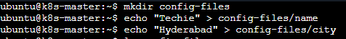
- Check the files: ls config-files
- You should see:
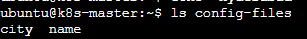
- Check their contents: cat config-files/name, cat config-files/city
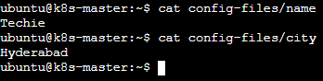

Step 4. Create ConfigMap from the directory
- kubectl create configmap app-config --from-file=config-files/
- Verify: kubectl get configmap app-config
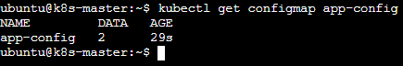
- To see the contents: kubectl describe configmap app-config
- You should see:
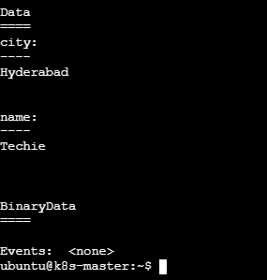

Step 5. Create a Pod and inject the ConfigMap as environment variables
- Create the YAML: vi configmap-pod.yaml and add
- Save and exit.
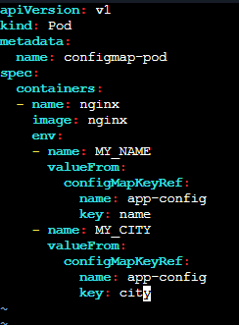

Step 6. Create the Pod
- kubectl apply -f configmap-pod.yaml
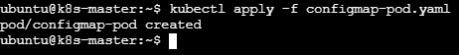
- Check: kubectl get pod configmap-pod
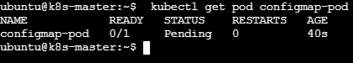
- Wait until it shows: Running
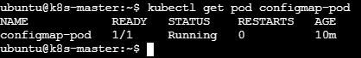

Step 7. Verify the environment variables
- Run: kubectl exec configmap-pod -- env | grep -E 'MY_NAME|MY_CITY'
- Expected:
MY_NAME=sabair
MY_CITY=Hyderaba
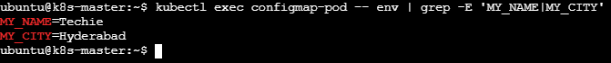

2. Create a ConfigMap from a file and mount it as a volume inside a pod, ensuring the configuration data is available as files.

Step 1. Create a configuration file
- echo "This is my application configuration" > app.conf
- Verify: cat app.conf
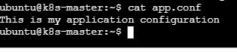

Step 2. Create a ConfigMap from the file
- kubectl create configmap app-config-file --from-file=app.conf
- Verify: kubectl get configmap app-config-file
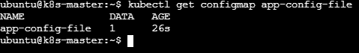
- Check the contents: kubectl describe configmap app-config-file
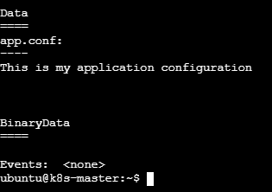

Step 3. Create the Pod YAML
- vi config-volume-pod.yaml and add
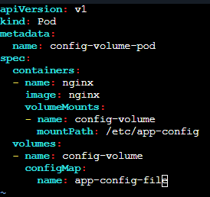
- Save and exit.

Step 4. Create the Pod
- kubectl apply -f config-volume-pod.yaml
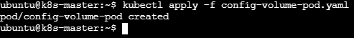
- Check: kubectl get pod config-volume-pod
- Wait until it shows: Running
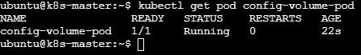

Step 5. Verify the configuration file inside the Pod
- kubectl exec config-volume-pod -- ls /etc/app-config
- Expected: app.conf
- Now read the file: kubectl exec config-volume-pod -- cat /etc/app-config/app.conf
- Expected: This is my application configuration

3. Create a Secret with sensitive information (username and password) and inject it into a pod as environment variables.

Step 1. Create the Secret
- You can create it directly with kubectl:
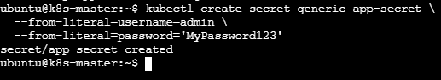

Step 2. Verify the Secret
- kubectl get secret app-secret
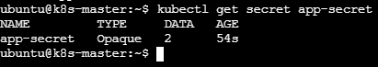

- For a real application, we shouldn’t put passwords directly in shell history or YAML files. This is fine for a Kubernetes lab.
- To check its keys: kubectl describe secret app-secret
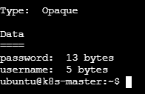
- The actual values are not displayed by describe.

Step 3. Create the Pod YAML
- vi secret-pod.yaml and add
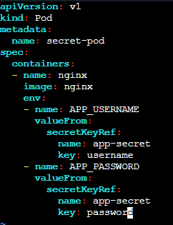
- Save and exit.

Step 4. Create the Pod
- kubectl apply -f secret-pod.yaml
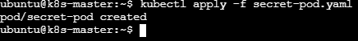
- Check: kubectl get pod secret-pod
- Wait until:
NAME | READY | STATUS
secret-pod | 1/1 | Running

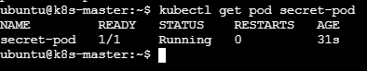

Step 5. Verify the environment variables
- kubectl exec secret-pod -- env | grep -E 'APP_USERNAME|APP_PASSWORD'
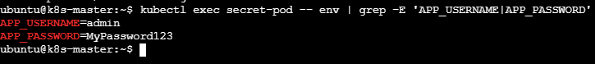

4. Create a Secret using a YAML file, mount it as a volume in a pod, and verify the specific Secret values are available as files.

Step 1. Create the Secret YAML
- vi secret-volume.yaml and add
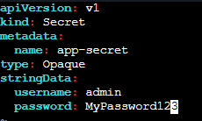
- Save and exit.

Step 2. Create the Secret
- kubectl apply -f secret-volume.yaml
- Verify: kubectl get secret app-secret
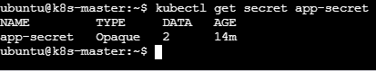
- You can check the keys: kubectl describe secret app-secret
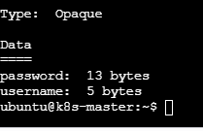

Step 3. Create the Pod YAML
- vi secret-volume-pod.yaml and add
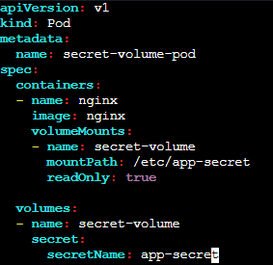
- Save and exit.

Step 4. Create the Pod
- kubectl apply -f secret-volume-pod.yaml
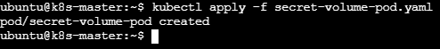
- Check: kubectl get pod secret-volume-pod
Wait for:
NAME | READY | STATUS
secret-volume-pod | 1/1 | Running

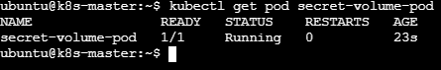
Step 5. Verify the Secret files
- List the files: kubectl exec secret-volume-pod -- ls -l /etc/app-secret
- Expected:
  - password
  - username
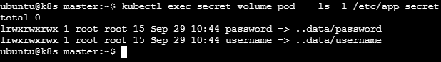

Step 6. Read the username
- kubectl exec secret-volume-pod -- cat /etc/app-secret/username
- Expected: Admin

Step 7. Read the password
- kubectl exec secret-volume-pod -- cat /etc/app-secret/password
- Expected: MyPassword123

5. Inject a ConfigMap as environment variables and a Secret as files into the same pod, ensuring both are accessible within the pod.

Step 1. Create the ConfigMap

Step 2. Create the Secret YAML
- vi app-secret.yaml and add
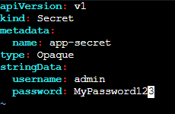

- Save and exit.
- Apply: kubectl apply -f app-secret.yaml
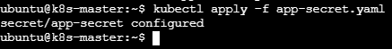
- Verify: kubectl get secret app-secret
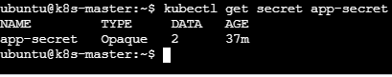
Step 3. Create the Pod
- vi config-secret-pod.yaml and add
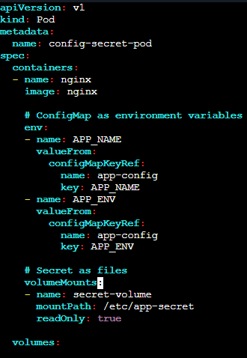
- Save and exit.

Step 4. Create the Pod
- kubectl apply -f config-secret-pod.yaml
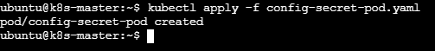
- Check: kubectl get pod config-secret-pod
- You should get:
NAME | READY | STATUS
secret-volume-pod | 1/1 | Running

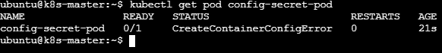

Step 5. Verify ConfigMap environment variables
- kubectl exec config-secret-pod -- env | grep -E 'APP_NAME|APP_ENV'
- Expected:
  - APP_NAME=myapp
  - APP_ENV=production

Step 6. Verify Secret files
- List the mounted files: kubectl exec config-secret-pod -- ls /etc/app-secret
- Expected:
  - password
  - username
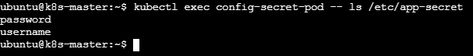
- Check username: kubectl exec config-secret-pod -- cat /etc/app-secret/username
- Expected: Admin
- Check password: kubectl exec config-secret-pod -- cat /etc/app-secret/password
- Expected: MyPassword123

